Infosys Springboard Virtual Internship 6.0 Completion Report

Team Details

BATCH NUMBER: 13 RECEIPT AND INVOICE DIGITIZER
START DATE: 02-02-2026
NAMES:
1) SAVULA SNEHITHA
2)VENKATA SAI PRANAVI GUDDANTI
3)BOOMA MANJUNATH
4)GYANA PRAVALIKA PERUGU
5) KUMMARI NIKHIL

Internship Duration: 8 Weeks

1. Project Title
Receipt and Invoice Digitizer

2. Project Objective

The Receipt and Invoice Digitizer is an AI-powered system designed to automate the process of converting physical receipts and invoices into structured digital data. The main objective of this project is to reduce manual data entry and improve the efficiency of financial document management for individuals and businesses. By using Optical Character Recognition (OCR) and machine learning techniques, the system extracts important information from uploaded receipts or invoice images such as vendor name, invoice number, date, item details, tax, and total amount. The extracted data is then organized and stored in a digital database for easy access and management. The tool provides a user-friendly interface and dashboard where users can upload documents, view extracted information, and manage their invoice records efficiently. It also helps in minimizing human errors, saving time, and improving accuracy in financial data processing.

3. Project description in detail

The Receipt and Invoice Digitizer is an advanced AI-based system designed to simplify and automate the process of managing financial documents such as receipts and invoices. In many organizations and businesses, handling large volumes of receipts and invoices manually is time-consuming and prone to human errors. This project addresses that problem by providing an intelligent digital solution that converts physical or scanned financial documents into structured and searchable digital data.
The system uses Optical Character Recognition (OCR) and Artificial Intelligence (AI) technologies to read and extract important information from uploaded images or PDF files of receipts and invoices. When a user uploads a document, the system processes the image, identifies text within the document, and extracts key details such as vendor name, invoice number, transaction date, item details, tax amount, and total amount. This extracted information is then organized into a structured format and stored in a database for easy access and management.
One of the major features of the Receipt and Invoice Digitizer is its user-friendly dashboard, which allows users to upload documents, view extracted data, and manage invoice records efficiently. The dashboard presents information in a well-organized format so that users can quickly search, filter, and retrieve specific invoices or receipts whenever required. This makes financial document management much more efficient compared to traditional manual record-keeping.
The system also includes data validation and error detection mechanisms to ensure that the extracted information is accurate. If the system detects missing or unclear data, it allows users to verify and correct the information before storing it permanently. This improves the reliability and quality of stored financial records.
Another important aspect of the project is its ability to support multiple document formats, including scanned images, photographs of receipts, and PDF invoices. The system processes these documents using intelligent preprocessing techniques such as image enhancement and noise reduction to improve the accuracy of text recognition.
As the system processes more documents, the AI component can continuously improve its performance by learning from previously processed data. This helps increase extraction accuracy over time and makes the system more efficient in handling different invoice formats.
Overall, the Receipt and Invoice Digitizer aims to create a smart and efficient digital solution for managing financial documents. By automating data extraction, reducing manual effort, and organizing records digitally, the system helps individuals and businesses maintain accurate financial documentation, save time, and improve overall productivity in financial management.

4. Timeline Overview
Week | Activities Planned | Activities Completed
Week 1 | Requirement gathering, understanding the problem statement, defining project scope, and assigning roles | Requirements finalized, project scope documented, and responsibilities assigned to team members
Week 2 | Research on OCR technologies and AI tools for invoice data extraction, selection of development tools and technology stack | OCR tools (such as Tesseract) studied and selected, tech stack finalized (Python, Flask/Django, HTML, CSS, JavaScript, SQL)
Week 3 | Database design and setup for storing invoice and receipt data | Database schema designed for storing vendor details, invoice number, date, amount, and tax information; tested with sample entries
Week 4 | Data collection and preprocessing of sample receipts and invoices for testing | Sample invoice and receipt images collected, image preprocessing techniques applied (noise removal, resizing, enhancement)
Week 5 | Development of OCR-based data extraction module for identifying text from invoices and receipts | OCR module implemented and tested to extract key fields such as vendor name, invoice number, date, and total amount
Week 6 | Development of user interface including upload feature and dashboard for viewing extracted data | Basic user interface created with document upload option and dashboard to display extracted invoice details
Week 7 | System integration: Connecting OCR module, database, and user interface | Successfully integrated OCR extraction with database storage and dashboard display for real-time processing
Week 8 | Testing, debugging, documentation, and final deployment of the project | System tested with multiple invoice formats, errors fixed, project documentation prepared, and final project deployed successfully

5a. Key Milestones
Milestone | Description | Date Achieved
Project Kickoff | Defined project scope, goals, and team responsibilities | 02-02-2026
Prototype Development | Implemented OCR-based receipt text extraction prototype | Week 4
Mid-Term Review | Evaluated system architecture and progress | Week 6
Final Submission | Completed system development and documentation | Week 8
Project Presentation | Presented project features and outcomes | Week 8

5b. Project execution details

- Requirement Analysis: The team studied the challenges of manual receipt management, including time-consuming data entry, difficulty in organizing receipts, and lack of financial visibility.
- Technology Selection:The system was built using Python with Flask framework, along with OCR technologies such as Tesseract and image processing tools like OpenCV.
- System Design: The system architecture included modules for user authentication, document upload, OCR processing, data extraction, database storage, and dashboard analytics.
- Data Collection: Sample receipt images and invoice PDFs were collected to test the OCR system.
- Data Preprocessing: Image preprocessing techniques such as grayscale conversion and thresholding were applied to improve OCR accuracy.
- OCR Development: The OCR module converts receipt images into text and extracts key fields using regular expressions (Regex) and parsing logic.
- Frontend Development: A user-friendly interface was developed using HTML, CSS, and JavaScript for uploading documents and viewing extracted information.
- Backend Development: The backend handles OCR processing, database storage, authentication, and API integration.
- Testing and Integration: The system was tested with multiple invoice formats to ensure accuracy and reliability.
- Deployment and Documentation: After final testing, the application was documented and prepared for demonstration and evaluation.

6. Snapshots / Screenshots

Step 1 : Clone the Project Repository

Go to GitHub and clone the project repository to your system. After cloning the repository, open the project folder using VS Code or any code editor to begin execution.

Example command:

git clone <your-github-repository-link>

Then open the folder in VS Code.

Step 2 : Install Required Dependencies and Start the Application

Navigate to the project directory and install the required Python dependencies.

Example:

pip install -r requirements.txt

After installing dependencies, start the application using:

python app.py

This will launch the Flask server for the Receipt & Invoice Digitizer system.

Step 3 : Landing Page Interface

After running the application, the user will see the Landing Page of the system.

The landing page provides navigation options such as:
- About
- Login / Sign Up
- Contact
- System Features

It helps users understand the application and access different modules easily.

Step 4 : User Authentication (Login / Signup)

Users must register or log in to access the system features.

New users:
- Create an account using the Signup option

Existing users:
- Login using their email and password

This authentication system ensures secure access to the application.

Step 5 : Upload Receipt or Invoice

After logging in, users are redirected to the User Dashboard.

Here users can:
- Upload receipt images (JPG / PNG)
- Upload invoice PDF files
- Drag and drop documents for processing

The uploaded document is sent to the OCR module for processing.

Step 6 : OCR Processing and Data Extraction

Once the document is uploaded, the system processes the image using OCR (Optical Character Recognition).

The OCR engine extracts text from the receipt and identifies key fields such as:
- Vendor name
- Transaction date
- Invoice number
- Total amount
- Tax details

The extracted information is converted into structured digital data.

Step 7 : Dashboard Display

After extraction, the processed information is displayed on the User Dashboard.

The dashboard shows:
- Uploaded receipts
- Extracted details
- Transaction records
- Expense summaries

Users can easily view and manage their receipt data.

Step 8 : Expense Details and Record Management

Users can open individual receipt entries to view detailed information including:
- Store or vendor name
- Purchase date
- Item details
- Total transaction value

This allows users to maintain organized digital financial records.

Step 9 : Analytics and Insights

The system provides visual analytics dashboards that display:
- Monthly spending trends
- Category-wise expenses
- Most frequent merchants
- Transaction summaries

Charts and graphs help users analyze their spending behavior.

Step 10 : Report Generation

Users can generate financial reports from the stored receipt data.

Reports can include:
- Expense summaries
- Transaction lists
- Spending analysis

These reports can be exported for documentation purposes.

Step 11 : AI Chatbot Assistance

The system includes an AI chatbot that allows users to interact with the application.

Users can ask questions such as:
- "What does this system do?"
- "How to upload receipts?"
- "How to view reports?"

The chatbot provides quick responses and guidance.

Step 12 : Contact Section

The Contact section allows users to communicate with the development team or administrators for support and feedback.

This ensures better user experience and assistance when needed.

End: The Receipt and Invoice Digitizer system successfully demonstrates the complete workflow from document upload to automated data extraction and digital record management.

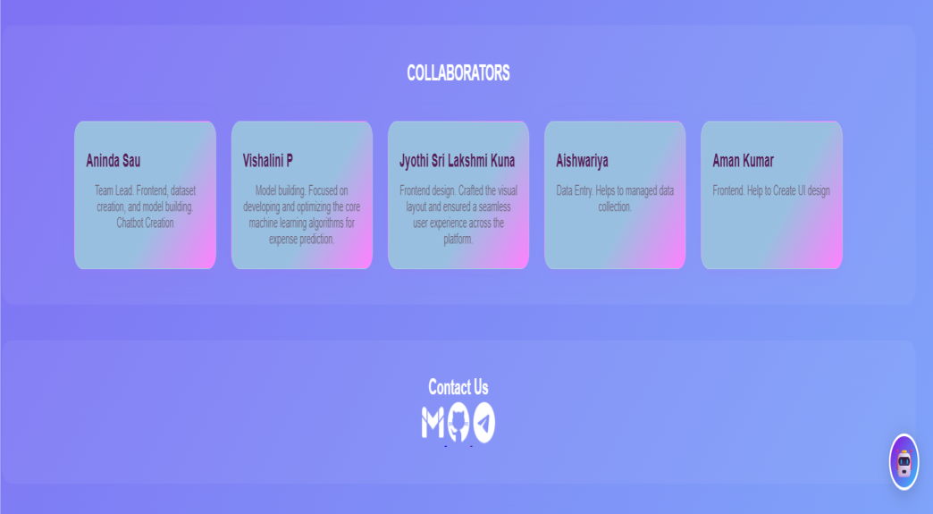

7. Challenges Faced

1. OCR Accuracy Issues: One of the major challenges was achieving high accuracy in extracting text from receipt images. Receipts often contain different fonts, layouts, and low-quality prints, which made it difficult for the OCR engine to recognize text correctly.

2. Poor Image Quality: Many receipts had issues such as low lighting, blur, shadows, or noise. These conditions reduced OCR accuracy and required preprocessing techniques such as grayscale conversion and thresholding to improve text visibility.

3. Variability in Receipt Formats: Receipts and invoices vary significantly between vendors and businesses. Different layouts, text positions, and formats made it challenging to create a universal extraction logic that works for all documents.

4. Data Extraction and Parsing: Extracting structured information such as vendor name, date, and total amount from unstructured OCR text required implementing pattern matching techniques using regular expressions (Regex) and custom parsing rules.

5. Integration of Multiple Modules: Integrating different components such as the Flask backend, OCR module, database storage, and user interface required careful coordination to ensure smooth data flow and system stability.

6. Handling Multiple File Formats: Supporting both image files (JPG, PNG) and PDF invoices required additional processing steps such as converting PDF pages into images before applying OCR.

7. User Interface Design: Designing a dashboard that is both simple and functional was challenging. The interface needed to allow users to upload documents, view extracted data, and analyze results easily.

8. System Performance: Processing high-resolution images and running OCR operations can be computationally expensive. Optimizing processing time while maintaining accuracy was an important challenge.

9. Error Handling and Data Validation: Sometimes the OCR system extracted incomplete or incorrect information. Implementing validation checks and allowing manual correction was necessary to maintain reliable data.

10. Time Management: Completing all stages of development—including research, implementation, testing, and documentation—within the 8-week internship timeline required efficient planning and teamwork.

8. Learnings & Skills Acquired

1. Understanding of OCR Technology
Through this project, we gained practical knowledge of Optical Character Recognition (OCR) and how it converts text from images and scanned documents into machine-readable data. We learned how OCR can be applied to automate document processing tasks.
2. Image Processing Techniques
We learned how to improve OCR accuracy by applying image preprocessing techniques such as grayscale conversion, thresholding, noise reduction, and image enhancement using computer vision tools like OpenCV.
3. Backend Development with Python and Flask
This project helped us gain experience in developing backend systems using Python and Flask framework, including routing, request handling, and server-side processing.
4. Text Parsing and Data Extraction
We learned how to extract structured information from unstructured OCR output using regular expressions (Regex) and pattern-based parsing methods to identify important fields such as vendor name, date, and total amount.
5. Database Management
We developed skills in designing and managing databases to store extracted receipt information. This included creating tables, storing transaction data, and retrieving records efficiently.
6. Frontend Development
We improved our frontend development skills using HTML, CSS, and JavaScript to create user-friendly interfaces such as login pages, dashboards, and document upload modules.
7. System Integration
The project helped us understand how different system components—OCR engine, backend server, database, and frontend interface—can be integrated to create a complete working application.
8. Data Visualization and Dashboard Design
We learned how to present financial information in a meaningful way using dashboards that display insights such as spending trends, receipt summaries, and transaction details.
9. Problem Solving and Debugging
During development, we faced multiple challenges related to OCR accuracy, system integration, and data extraction. Solving these issues improved our debugging and analytical skills.
10. Team Collaboration and Project Management
Working in a team environment helped us improve communication, coordination, and task management skills while following a structured development process throughout the internship.

9. Testimonials from team

Team Member 1:
“This project helped me understand how OCR technology can automate document processing and reduce manual work.”

Team Member 2:
“I learned how to build a complete web application that integrates image processing, databases, and dashboards.”

Team Member 3:
“Working on this project improved my collaboration skills and taught me how to design scalable software systems.”

Team Member 4:
“This project enhanced my understanding of AI-based automation and strengthened my confidence in building real-world applications.”

10. Conclusion

The Receipt and Invoice Digitizer project successfully demonstrates how OCR technology and web development can be combined to automate financial document management. The system enables users to upload receipts and invoices, automatically extract important data, and store it in a structured digital format.
By reducing manual data entry and improving data organization, the platform helps individuals and businesses manage their financial records more efficiently. The project also provided valuable learning opportunities in OCR processing, backend development, and system integration.

Acknowledgements
We would like to express our sincere gratitude to Infosys Springboard for providing the opportunity to participate in this virtual internship program.
We are especially thankful to our mentor for their valuable guidance and support throughout the project development process. Their feedback and insights helped us overcome technical challenges and improve our system.
We also appreciate the efforts and collaboration of all team members who contributed to the successful completion of the project.
Finally, I appreciate everyone who contributed directly or indirectly to my learning and the completion of this project.

